Phase 1: Fleet Orchestration & Deployment

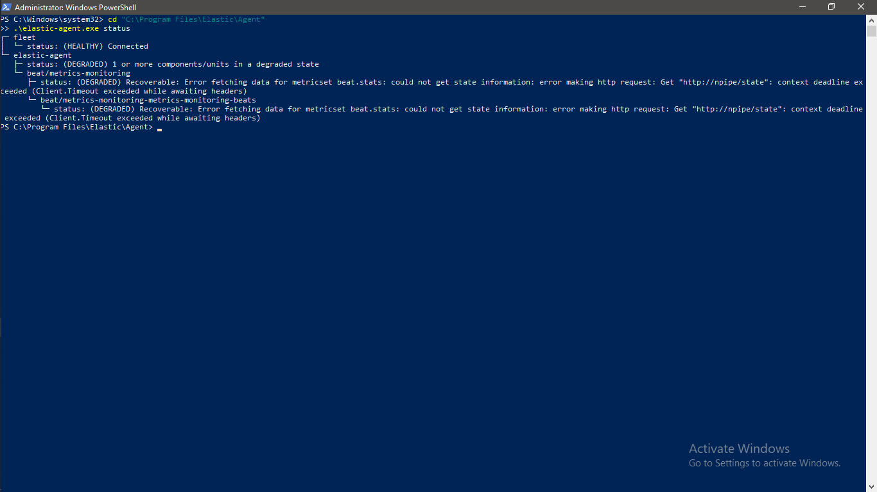

PowerShell window showing 'Elastic Agent successfully installed’

Phase 2: Custom Rule creation

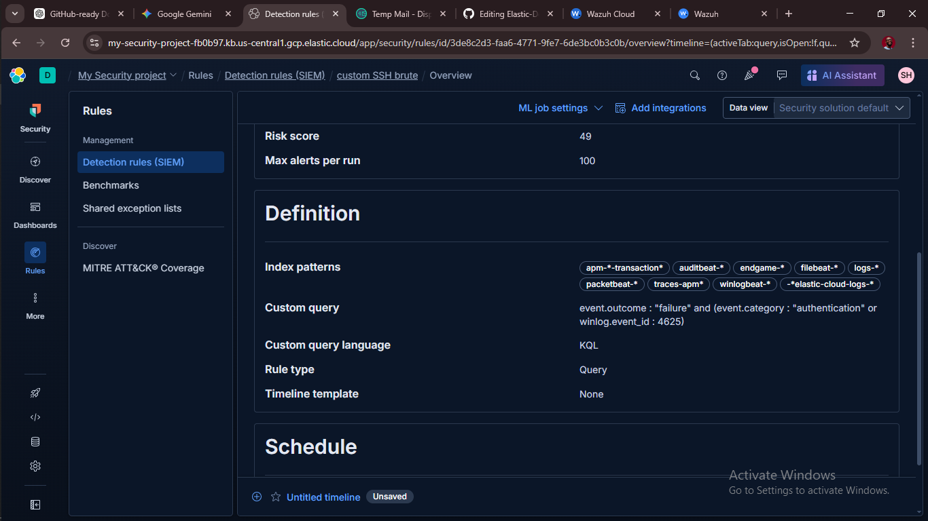

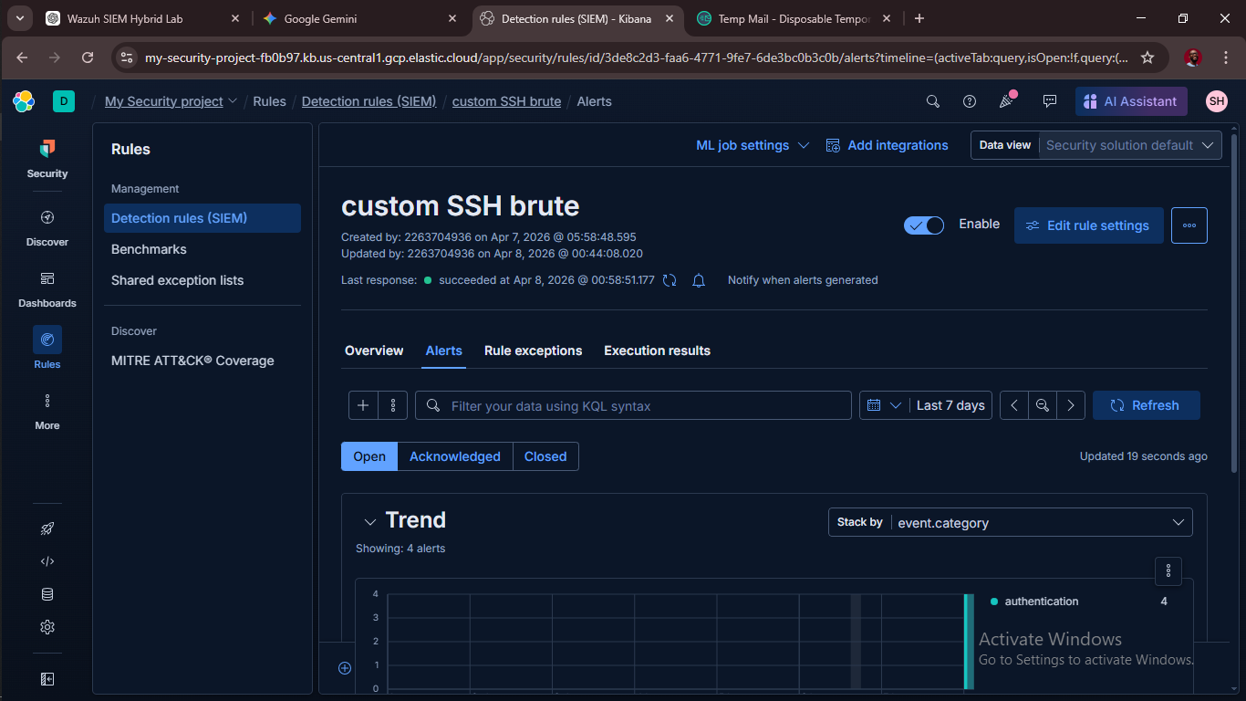

Elastic Rule Editor showing the custom query
Phase 3: Alert Validation

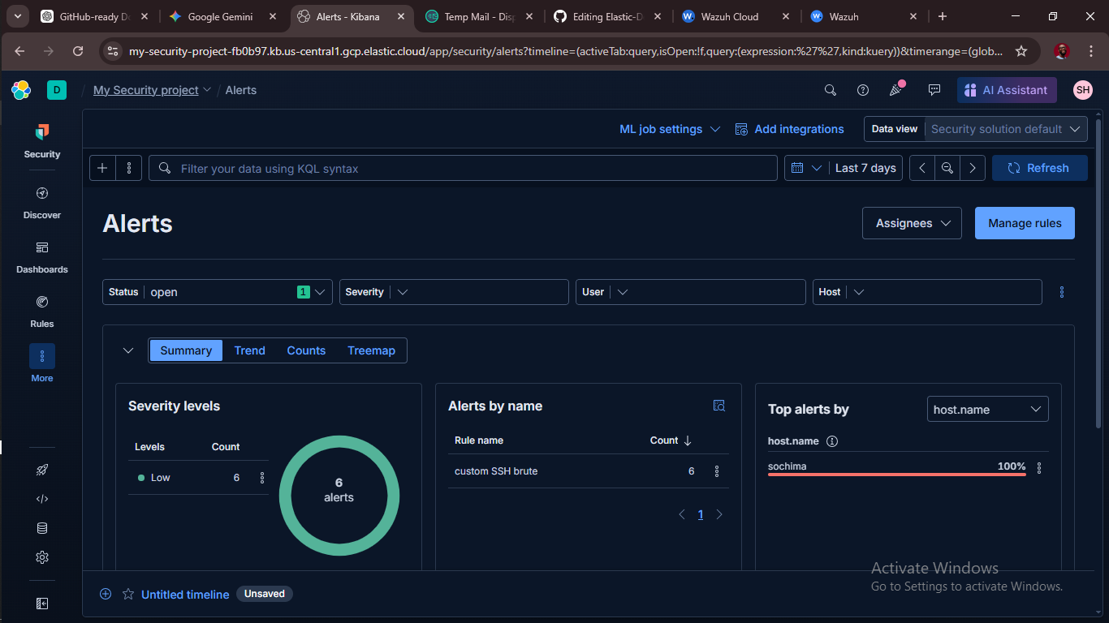

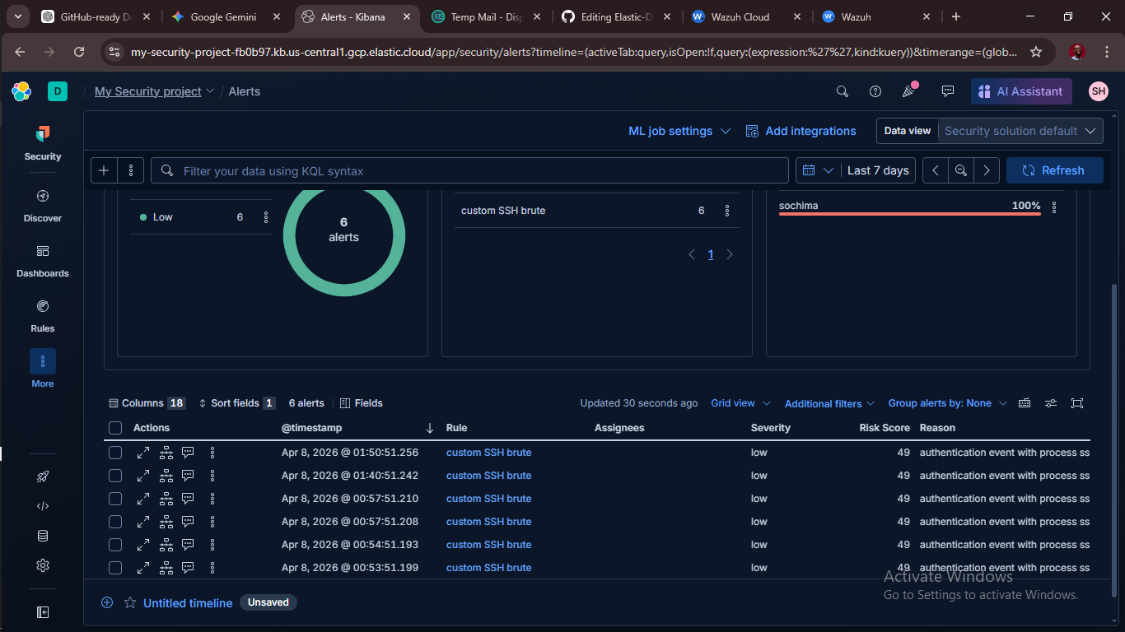

Elastic Alerts dashboard showing your alert

Phase 4: The "Under the Hood" JSON

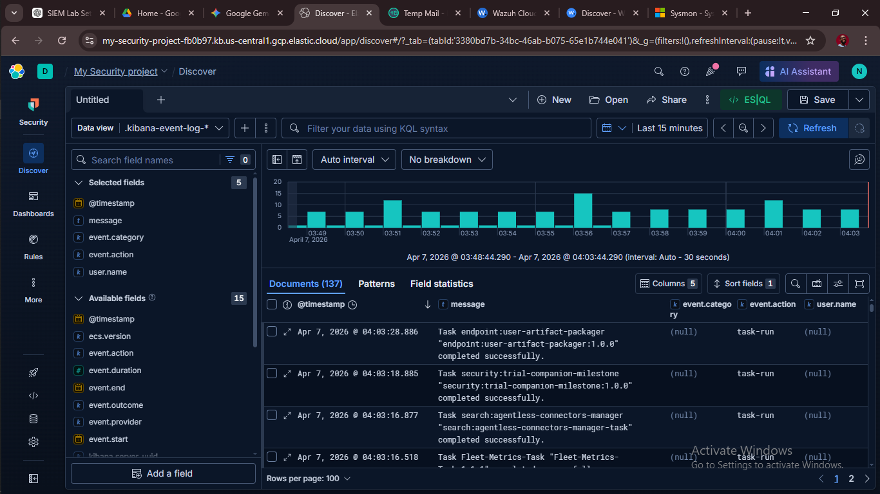

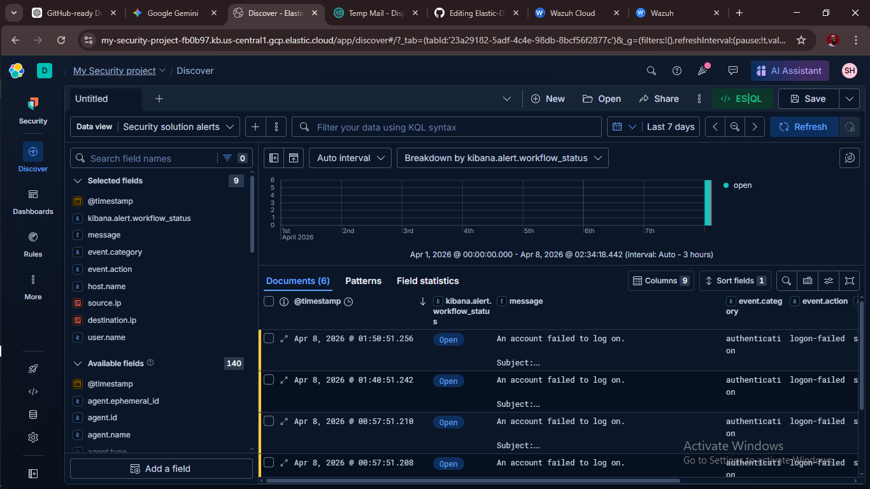

Raw JSON / Discover

